On the Cultivation of Tobacco:
A Research Report

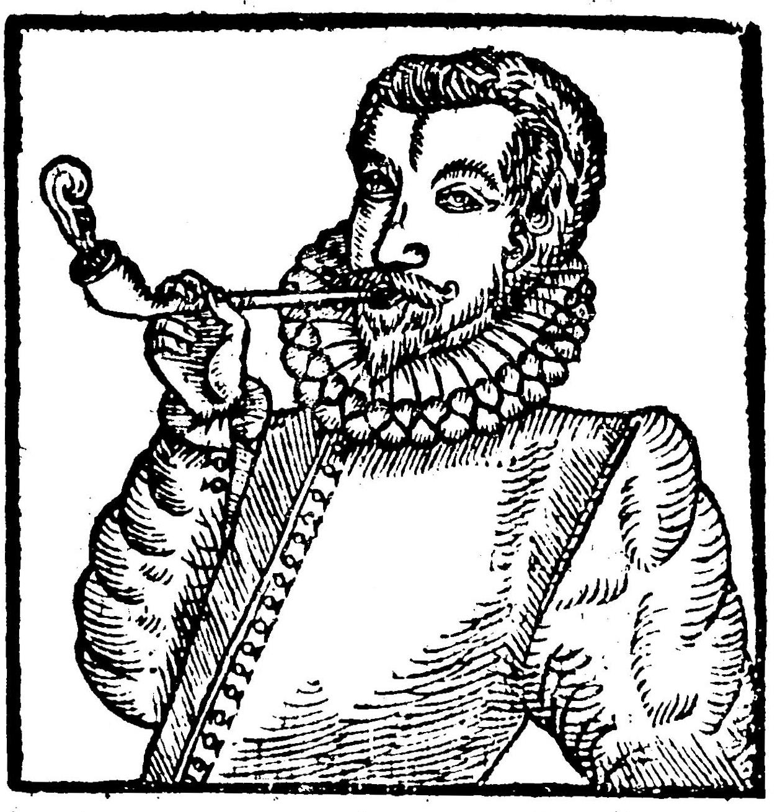

Lady Elinor Strangewayes, OM.
Shire of Mountain Freehold.
Overview: This paper is the result of a four-month experiment in tobacco cultivation and processing, following the advice laid down in several late period English guidebooks and tracts on tobacco.

On Christopher Columbus’ first expedition, he encountered native peoples who offered “fruit, wooden spears, and certain dried leaves which gave off a distinct fragrance.” The Europeans ate the fruit, admired the spears, and accepted the plants for politeness’ sake as the natives seemed to value them highly. Once the natives were out of sight, Columbus threw the leaves away. Despite this poor beginning, these same dried leaves would eventually be just as valuable in Spain as they had been in the Caribbean. The plant, of course, was tobacco, and its cultivation and use would spark passionate debate, national conflict, and dreams of profit. Numerous manuals were published to offer advice on everything from its cultivation to its association with sin. This paper is the result of an attempt to grow tobacco following the advice of the sixteenth and early seventeenth century guidebooks.
Tobacco was a highly controversial subject to the societies of the 16th and early 17th centuries. Supporters claimed it would cure everything from melancholy to sexually transmitted diseases, while detractors railed against it as the Devil’s creation and a threat to civilization. Its cultivation proved to be the savior of many fledgling New World colonies that had found the promises of easy gold to be false. By 1615, Caribbean tobacco was being sold for 10 times the price of pepper, and the best of it was valued pound for pound with silver. At the same time, some concerned authors worried that it was killing the nation’s youth (one physician wrote that he wished “it were as well knowen by the name of Youths-bane, as by the name of Tabacco”). More pragmatic voices expressed concern that “the Treasure of this land [was being] vented for smoke” as the Spanish colonies no longer accepted goods in trade for tobacco, only silver, gold, and silks.
While tobacco was initially collected by Iberian explorers who extorted it from the native peoples they encountered, by the second quarter of the 16th century it was easier to grow it on organized tobacco plantations established under colonial supervision. Demand for the herb increased as its use spread beyond the Iberian Peninsula and Spanish holdings in the Caribbean. English sailors working in the Caribbean in the 1560s picked up the habit, and tobacco use among the English was a predominantly maritime trait until it went mainstream via the Virginian colonists. William Camden, an early scholar and historian, was present at Plymouth (England) in July of 1586 when a boatload of returning Virginians publicly disembarked with their pipes and smoking pouches. Camden later noted that “these men which were brought backe were the first that I know of, which brought into England that Indian plant which they call Tabacca, and Nicotia.” Its use spread rapidly among the fashionable with Sir Francis Drake introducing Sir Walter Raleigh to the habit in 1585, and Queen Elizabeth herself eventually tried it.
With tobacco’s popularity on the rise, people in the New World began sending seed home in hopes of establishing this cash crop on their own side of the Atlantic without the expense and danger of several months’ sea voyage. Small-scale importation of seed had been occurring throughout the early and mid 1500s, but the second half of the 16th century saw an explosion in botanical interest. Spanish doctor Nicholas Monardes noted that herbalists were growing tobacco all over Spain when he wrote De Hierba Panacea in 1571. Books such as Anthony Chute’s 1595 work Tabacco and the anonymous New and short defense of tabacco of 1602 offered advice to the public on the subjects of tobacco’s cultivation and medicinal properties.
In light of those and similar works, I decided to cultivate a little tobacco myself, following the gardening advice of these authors. I obtained some Nicotiana rustica seed from Plimoth Plantation in the winter of 2007-2008. Later research revealed that this is a variety generally held to be non-smokable, though it’s worth pointing out that I am not the first to make the mistake – it was not until 1530 that Mexican missionary Bernardino de Sahagun distinguished between Nicotiana tabacum and Nicotiana rustica. (N. tabacum is the variety commonly used commercially for smoking purposes; N. rustica is harsh and most often employed by gardeners to keep bugs away.)
Period authors suggest that tobacco requires “the hottest and most fertill ground” that can be found, preferably “where the sunne shineth most, and if it be possible against some wall which may defend it from the North winde, which is an infinite enemy to this hearbe.” It should be sown a dozen seeds to a hole, three inches deep. This seems like a lot of seed, but they are tiny and delicate. Author “C. T.” of the 1615 Advice How to Plant Tobacco takes a different approach. His book says the seed can be simply strewn on the surface of the soil at nearly any time of year, the only concern being that if the seeds are too deeply covered with soil and planted too late in the spring, they will not come up in time to ripen before frost.
Regarding the best time of year for planting, Anthony Chute writes that it is best to plant it in March in England, though other authors have recommended April. Personally, I live in a climate much colder than England, and my house is not entirely heated. (I cannot grow houseplants in the winter, for the house routinely falls below freezing inside.) Therefore, I had to wait until mid-April before it was warm enough to plant my seeds.
I obtained a set of biodegradable potting cups for my seed, as all the authors agreed that this is a plant that is started in one location and set out in another to mature. I planted about 12-18 seeds and ended up with 6 plants. C. T. recommends that “After your seedes are growne up to a stalke of three inches high, you must take them up and replant them, leaving two foot betweene each plant of the lesser kind, and three foote between each of the greater.” The seedlings’ height is carefully calculated - if they are left to grow too tall before transplant they will be damaged in the repotting and take too long to recover.
My seedlings were about that height when I removed them to their final location. In late May, I dug a garden on Star Island, the largest of the New Hampshire-owned islands in the Isles of Shoals off the coast near Portsmouth NH. (I live and work there during the summer.) Anthony Chute recommends that the seedlings should be replanted “neer some wal, within two or three foot, but if the ground be not good there, (as commonly it may happen) then prepare with apte manuring it.” I dug a raised bed garden in a sheltered space behind the cottage where I worked. At home in Vermont, we own horses, so I was able to bring out multiple 5-gallon pails of composted manure to supplement the island soil. My plants never reached the nine or ten feet tall that Chute claimed some would, but even Chute admitted that such height would be exceptionally lucky. This may have had something to do with my haphazard watering schedule – though C. T.’s book ordered gardeners to “take care to water your plants once a day: in the morning, if the Spring be cold; in the evening if it bee warme,” I watered mine 5-7 times a week whenever my work schedule allowed.
The tobacco grew merrily all summer. When it was about a foot tall, it began budding and sending off side-shoots, which I clipped every day in accordance with the rules laid down in An Advice How to Plant Tobacco. The end result should be 8-10 leaves upon one central stalk. The author of the Advice warned greedy gardeners to follow this rule strictly, for if the side shoots were left to grow out of a desire for more leaves, the tobacco would be “weake and worth nothing.” I did allow one plant to go to seed on a side-shoot because I wanted seed for next year. Given that I was using an inferior variety of tobacco to start with, I doubt it hurt my quality too much.
As the end of summer approached, the tobacco began ripening. The ripe leaves could be identified by being “full of yellow spottes, which you shal best discerne if you hold a leafe between you and the light. Harvesting the leaves was a fairly simple matter, though staggered over the course of a week as they did not ripen at once. I picked the ripe leaves in the last week of August. The author of the Advice How to Plant Tobacco suggested that the leaves should be laid to wilt for a few hours and then hung on a string to dry, or laid on a clean boarded floor until they become yellowish. Anthony Chute’s 1595 book reports that the “Indians of Trinidade” lay tobacco “in the shadow,” “where no wind or sunne come to draw out the power or vertue in exhalations.” For two days my leaves withered upstairs in my (very hot and unventilated) attic before being strung. It was a common practice for untrustworthy tobacco merchants to dye their products at this point or dip them in various solutions to make poor quality tobacco appear better grade.
This is a subject that appears frequently in tobacco literature – anti-tobacco tracts warn of the foul ingredients used in its manufacture. Philaretes, who wrote Work for Chimnysweepers in 1602, boldly asserted on his title page that it was “better [to] be chokt with English hemp, than poisoned with Indian Tabacco.” Even tobacco supporters feared that foreign tobacco was often deliberately contaminated by “Spanish slaves [who] make it up, how they dresse their sores, and pockie ulcers, with the same unwasht hands with which they slubber and annoynt the Tobacco, and call it sauce Per los perros Luteranos, for Lutheran dogges.” I did not treat my tobacco in any way, though one alleged Spanish recipe sounded like it would possibly improve my batch: “a kinde of juyce, or syrope, made of Saltwater, of the dregges or filth of sugar, called Malasses, of black honey, Guiana pepper, and leeze [dregs] of Wine.” Another called for “blacke spice, galanga, aqua vitae, Spanish wine, Anise seeds, oyle of Spicke [possibly oil of spike, made from lavender] and such like.” The leaves at this point of the process were a tawny golden brown, the natural ideal according to several of the authors.
After drying some, the tobacco leaves are then left to ferment “in heapes, in a heat somewhat stronger than a hot-house.” I put my leaves into ziplock bags, as I did not have enough leaves to create the heavy, moist piles necessary to make them “sweat.” The leaves then undergo a sort of fermentation for an unspecified period of time. Apparently this is something that both C. T. and Anthony Chute assumed that the reader would already know. The only hint is a reference from C. T. advising tobacco connoisseurs to seek out the “deep yellow, or slight tawny, which colours are naturall, and forbeare the blacke which is foule, the dyed Tobacco, which is red, and the leafe brought in by the Portugalles, and the like slubbered stuffe.” I put mine in sealed plastic bags in a hot attic for several weeks and used my best guess as to temperature and duration. A small amount of foul-smelling fluid appeared at the bottom of one of the bags after the first week, so I drained it and from then on left the bags open. That appears to have done the trick, and at the end of two weeks the leaves were mostly dry and a pretty yellow-green color.
I have tried to smoke this tobacco once or twice. It was not pleasant. [Nota bene: I’m not a regular smoker by any means; I own a reproduction clay pipe out of historical interest and only rarely use it.] The anonymous author of the 1602 New and Short Defense of Tabacco claims that tobacco “dooth leave behind it, in my mouth (taken by pipe) a certain sweet fragrant moisture, Referens mellitum quid, not much unlike the pleasant deaw on oken leaves, in prime of Maie, whereuppon Hony-bees, at that time, do most commonly and comfortably feede.” Regarding my tobacco, it did not so much taste like a pleasant dew as something you might use to kill the aforementioned bees. As previously mentioned, however, I made the mistake of planting Nicotiana rustica instead of Nicotiana tobacum. To judge from the advice books, though, I am not the first to find tobacco unpleasant to the palate. The same anonymous author above offers the following advice for smokers: “When you take it by Pipe, mine advice is, that you put into your box of prepared powder, one grain at the least, of the oile of Anniseedes, it will give your powder a marvellous grace, and comfortable, both to the smell, and taste, of the taker, not only pleasant and delectable, but also profitable and commendable, especially to the daintier sort.”
I attempted to grow this tobacco out of curiosity to see if the advice laid down in contemporary guidebooks would produce a viable product. The major error, in seed selection, was mine. Although the major authors differed with each other in detail, their advice was sound and my adventure in tobacco cultivation mirrored their experiences. (Except, perhaps, for the production of a marketable product at the end.) I suspect that if I tried this again with the proper N. tobacum seed, the results would be much better. The tobacco-related literature offers a fascinating glimpse into Elizabethan concepts of health, agriculture, and social order. There is much potential for future research into how tobacco and its related spheres of material culture and economy fit into the transatlantic world at the dawn of the seventeenth century.

Bibliography.
Primary Sources.

- Anonymous. A New and Short Defense of Tabacco. Printed by Clement Knight: London, 1602.
- Barclay, William. Nepenthes or The Vertues of Tabacco. Andro Hart: Edinburgh, 1614.
- C. T. An Advice how to Plant Tobacco in England. Printed by Nicholas Okes: London, 1615.
- Camden, William. Annales Rerum Gestarum Angliae et Hiberniae Regnante Elizabetha, 1615. Published online by Dana Sutton, March 27, 2000. [http://www.philological.bham.ac.uk/camden/] Accessed Feb 28 2009.
- Chute, Anthony. Tabacco. Printed by William Barlow: London, 1595.
- Columbus, Christopher and de las Casas, Bartolomé. (Samuel Kettell, translator.) Personal Narrative of the First Voyage of Columbus to America. Boston: T. B. Wait and Son, 1827. Available online via Google Books. [http://books.google.com/books?id=iaDtUahGNf4C] Accessed Feb 28, 2009.
- Duncon, Eleazar. The Copy of a Letter. Melchisedech Bradwood: London, 1606.
- James I, King of England. A Counterblaste to Tobacco. Printed by R. B.: London, 1604.
- Marbecke, Roger. A Defence of Tabacco, Printed by Richard Field: London, 1602.
- Philaretes. Work for Chimnysweepers, Printed by T. Este: London, 1602.

Secondary Sources.
- Borio, Gene. “The Tobacco Timeline.” [http://www.tobacco.org/History/Tobacco_History.html] Accessed Feb 28, 2009.
- Gilman, Sander L. and Zhou, Xun. Smoke: A Global History of Smoking. Reaktion Books, 2004.
- Harris, Mark (Lord Stefan li Rous), ed. “Smoking-msg,” from the Florilegium. [http://www.florilegium.org/] Accessed Feb 28, 2009.

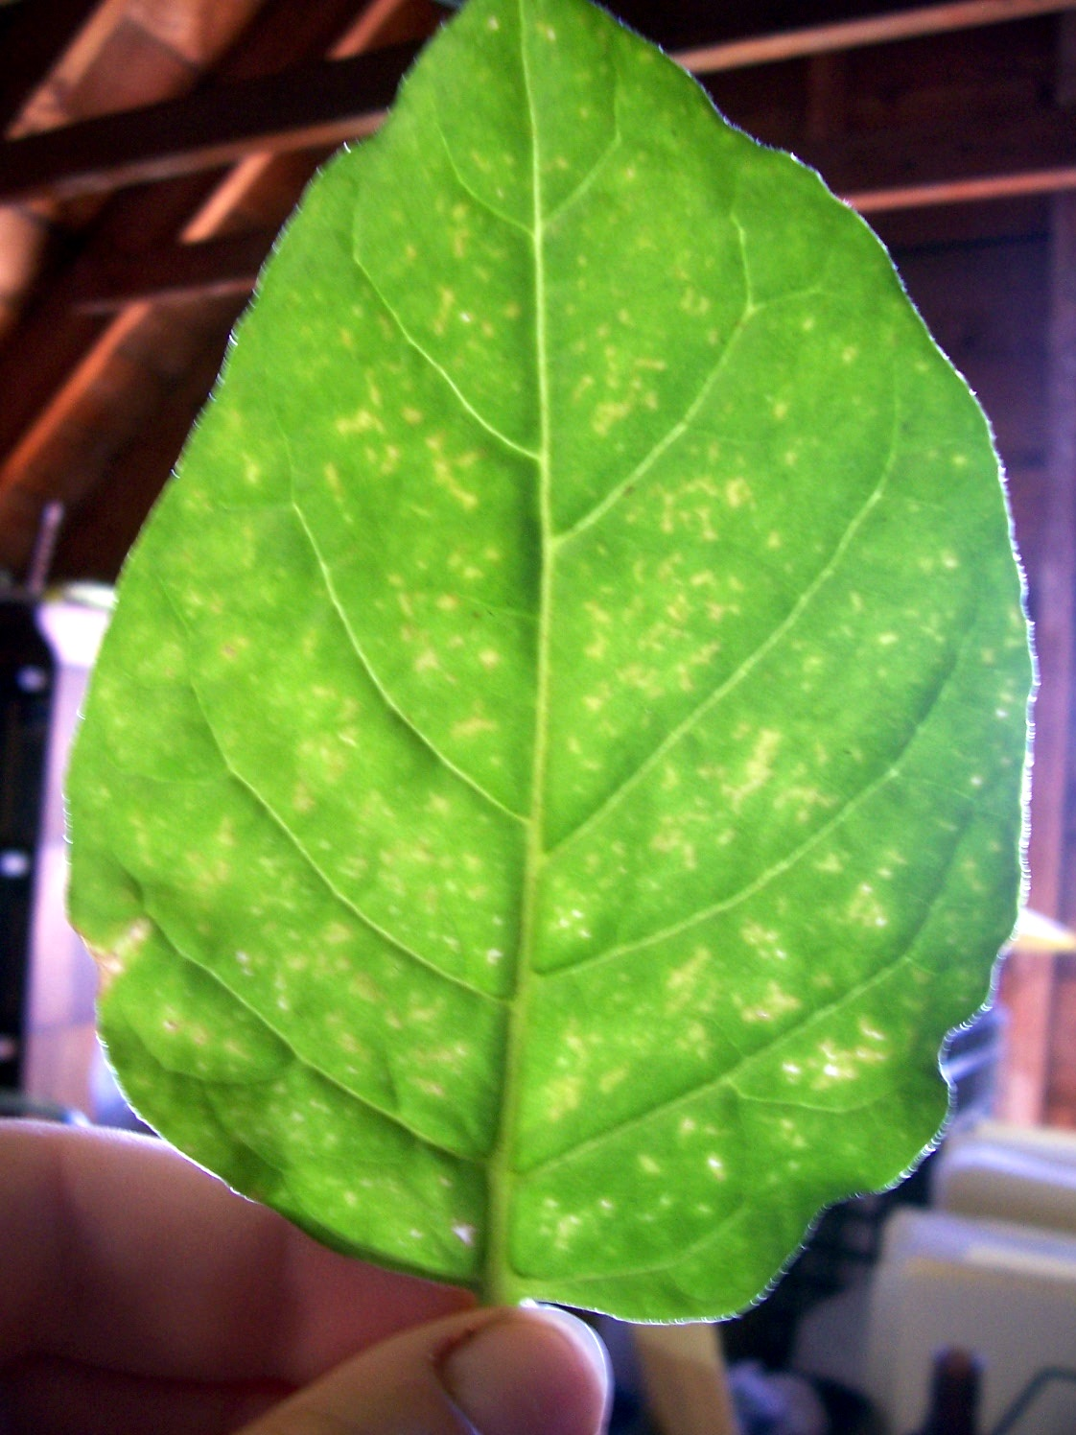
Appendix: Photos

“When your leaves be towards ripening, they will bee full of yellow spottes, which you shal best discerne if you hold a leafe between you and the light.”

Fresh-picked and partially-dried leaves, with a US quarter for scale. 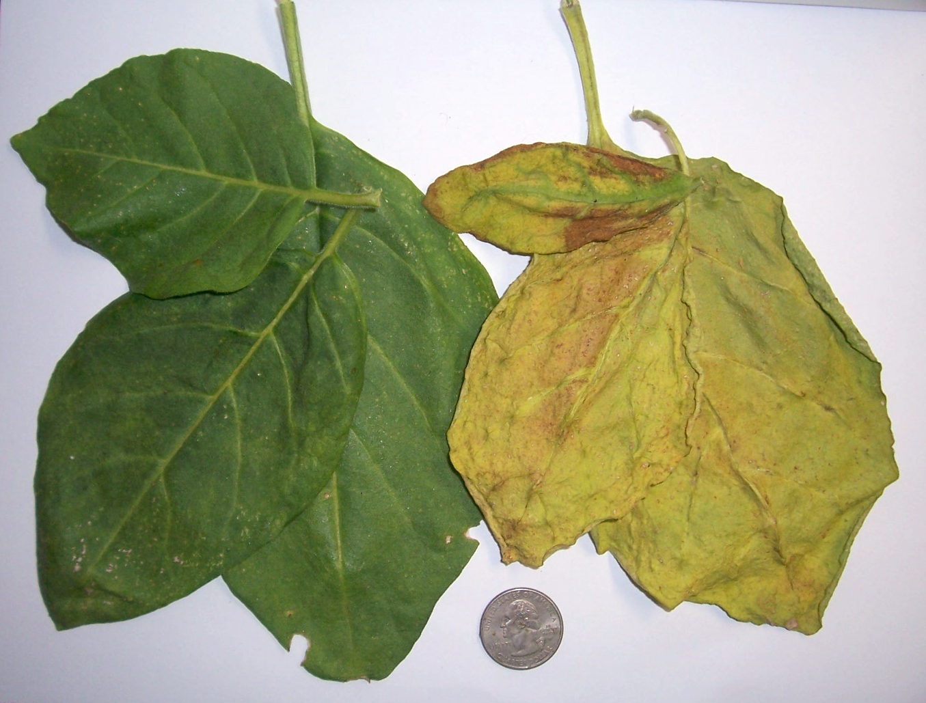

Journal of Christopher Columbus, 12 October 1492, quoted in Smoke: A Global History of Smoking by Sander L. Gilman and Xun Zhou. Reaktion Books, 2004. Page 30.
C. T. An Advice how to Plant Tobacco in England. Printed by Nicholas Okes: London, 1615. Page 3.
Duncon, Eleazar. The Copy of a Letter. Melchisedech Bradwood: London, 1606. Page 5.
C. T. 13
Camden, William. Annales Rerum Gestarum Angliae et Hiberniae Regnante Elizabetha, 1615. Published online by Dana Sutton, March 27, 2000. [ http://www.philological.bham.ac.uk/camden/ ] Accessed Feb 28 2009.
Borio, Gene. “The Tobacco Timeline.” [ http://www.tobacco.org/History/Tobacco_History.html ] Accessed Feb 28, 2009.
Chute, Anthony. Tabacco. Printed by William Barlow: London, 1595. Page 39.
Chute 41
C. T. 5
Chute 42
C. T. 6
Chute 43
Chute 37
C. T. 6
C. T. 6
C. T. 6
C. T. 6
C. T. 6
Chute 6
Philaretes. Work for Chimnysweepers, Printed by T. Este: London, 1602. Page 1.
C. T. 4
C. T. 3
Barclay, William. Nepenthes or The Vertues of Tabacco. Andro Hart: Edinburgh, 1614. Page 5.
C. T. 7
C. T. 7
Anonymous. A New and Short Defense of Tabacco. Printed by Clement Knight: London, 1602. Page 3.
Anonymous. A New and Short Defense of Tabacco, 14.
C. T. 6

